QuickLoan Governance Review Card
This Card summarizes the key data governance risks and recommended mitigations for the QuickLoan Mobile platform
Section | Issue / Definition | Impact | Suggested Mitigation
1.Data Quality Risk | Inconsistent Identity Data: Lack of standardized format for phone numbers and Ghana Card IDs. | High loan default rates due to failed identity verification and fragmented user profiles. | Implement real-time regex validation in the mobile UI and a standardization layer in the Preprocessing Service.
2.Legal & Compliance Risk | Unauthorized PII Harvesting: Excessive collection of contact lists without explicit granular consent. | Severe legal penalties under Ghana’s Data Protection Act (Act 843) and loss of operating license. | Implement a mandatory Consent Management screen and adopt Data Minimization—collect only what is essential for credit scoring.
Data Classification | Sensitive | Unauthorized access leads to identity theft and financial fraud for Ghanaian citizens | Encrypt all data at rest and implement strict Role-Based Access Control (RBAC).
3. Bias & Fairness Risk | Network Effect Bias: ML model using “Contact List Size” as a proxy for creditworthiness. | Systemic discrimination against low-income users or marginalized groups with smaller social networks. | Remove contact list data from the feature set and introduce Fairness Auditing to monitor True Positive Rate (TPR) parity.
Source of Bias | Proxies for Socio-economic Status (e.g., Device type, Contact density). | Reinforces existing wealth gaps by denying loans to those most in need. | Conduct regular Bias Stress Tests on the ML model using synthetic demographic data.
4. Storytelling / Reporting | Approval Rate Disparity (ARD) | Measures the difference in loan approval rates between demographic groups. | Monthly transparency reports to the Board and regulatory bodies.
Metric to Monitor | ARD Index = (Approval Rate of Group A) ÷ (Approval Rate of Group B) | Provides a simple fairness score for non-technical stakeholders. | N/A
Visualization Type | Grouped Bar Chart | Highlights gaps in approval rates across regions or age groups | N/A
Why It Matters | Transparency ensures automated decisions are | N/A | N/A

Deliverable 2: Corrected Data Flow Diagram
The following diagram illustrates the ethically governed data pipeline. Numbered annotations explain the specific corrections made to mitigate the risks identified in the internal audit
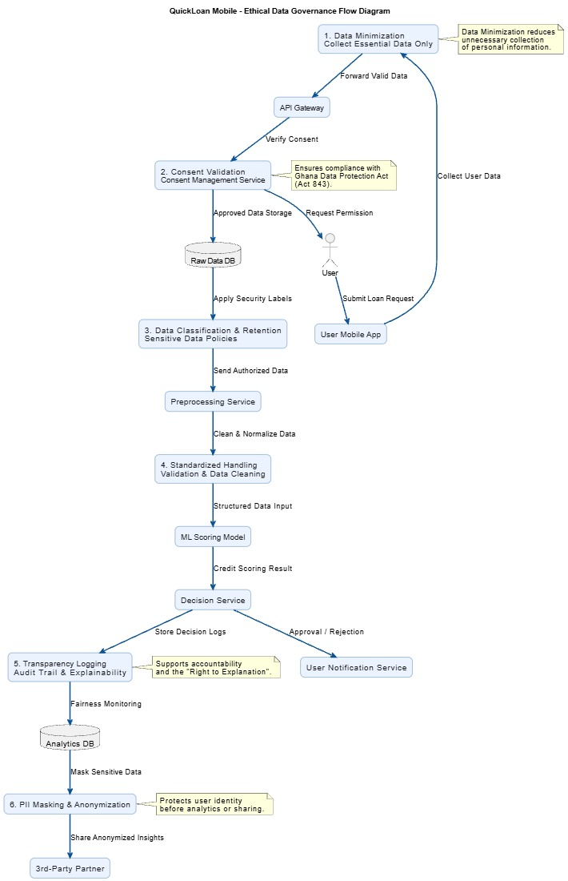

Governance Annotations

1. Implement Data Minimization (Step 1)
Reduced collection at the source. The application now requests only essential financial and identity information, removing the “Entire Contact List” requirement to protect user privacy and comply with Ghana’s Data Protection Act (Act 843).

2. Consent & Compliance Gate (Step 2–3)
A dedicated Consent Service has been introduced. Data is stored in the Raw Data Database only after the user provides explicit and granular consent for loan processing, ensuring legal and ethical compliance.

3. Data Classification & Retention (Step 3)
The Raw Data Database now classifies information as “Sensitive” or “Confidential.” Automated retention policies are applied to securely delete records once the loan lifecycle or legal retention period expires.

4. Defined Handling & Cleaning (Step 4)
The Preprocessing Service now performs strict data quality checks, including normalization of phone numbers and Ghana Card IDs, ensuring high-quality inputs for the machine learning model.

5. Transparency & Audit Logging (Step 7)
The Decision Service records the logic, features, and reasoning used for every automated approval or denial decision. This supports manual review processes and provides users with the “Right to Explanation.”

6. PII Masking & Anonymization (Step 9–10)
Data transferred to the Analytics Database and Third-Party Partners is masked using techniques such as hashing names and truncating identification numbers. This protects user identity while still enabling analytics and partnership operations.

Deliverable 3: Summary of Review Process(200-300 words)
In my role as an Independent Data Governance Consultant, my review process for QuickLoan Mobile focused on aligning the automated micro-loan pipeline with the ethical and legal standards of Ghana’s Data Protection Act (Act 843). I utilized the Data Lifecycle framework to analyze every touchpoint of borrower data, from initial collection at the mobile application level to eventual sharing with third-party partners. By mapping the data flow, I identified critical failure points where Data Minimization was ignored, specifically in the excessive harvesting of user contact lists which posed a significant legal and ethical risk.
To address these risks, I applied Data Classification principles, categorizing identity and financial records as "Sensitive." This classification drove the implementation of a "Governance Layer" in the corrected diagram, which introduces mandatory consent validation and PII masking. These technical controls ensure that while data remains useful for analytics, the privacy of the individual is preserved throughout the lifecycle. By classifying data early, we can apply specific retention and encryption policies that mitigate the impact of potential data breaches.
Furthermore, I proposed the Approval Rate Disparity (ARD) metric to ensure ethical and transparent governance. This metric serves as a key performance indicator (KPI) for fairness, allowing the company to monitor whether its ML model is inadvertently discriminating against specific demographics based on social proxies. By visualizing this metric through grouped bar charts, QuickLoan transforms a complex, "black-box" algorithmic process into a transparent reporting mechanism. This level of storytelling is essential for maintaining trust with the Ghanaian public and demonstrating accountability to the Data Protection Commission. Through this structured approach of lifecycle mapping, classification, and metric-driven accountability, QuickLoan can transition from flawed data practices to a gold standard in ethical fintech.

